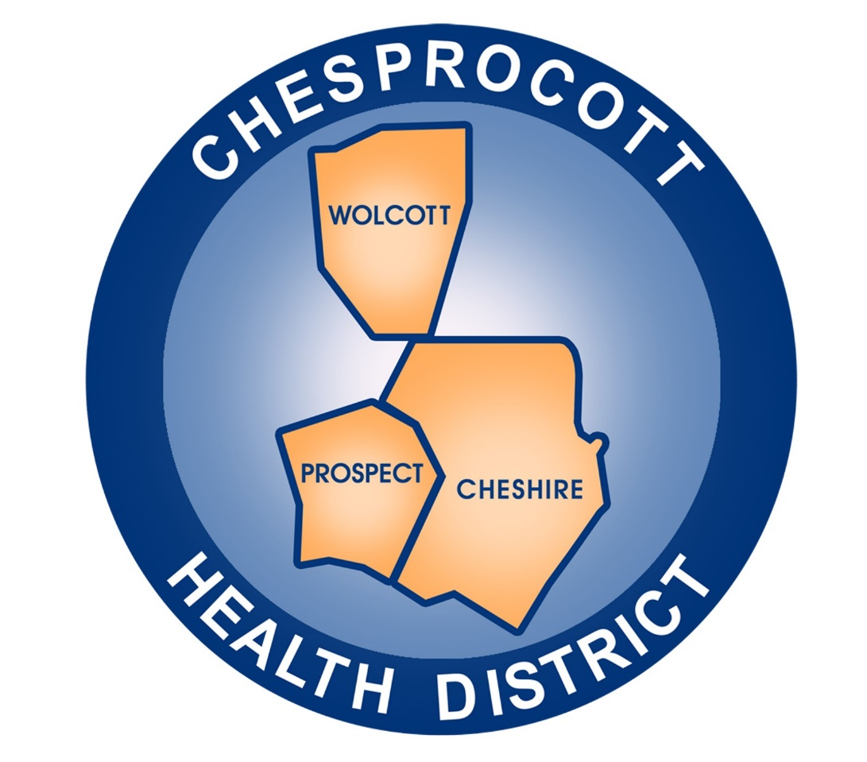
Chesprocott Health District

Annual Report 2023-24

Message From the Acting Director

Dear Community Members, Partners, and Stakeholders,
It is with great pride that I present to you the Chesprocott Health District’s Annual Report for Fiscal Year 2023–2024. We are dedicated to protecting and promoting the health and well-being of the residents of Cheshire, Prospect, and Wolcott.
This past fiscal year has been one of growth, innovation as well as change. Our team has worked tirelessly to provide the ten essential public health services, from disease prevention and environmental health inspections to health education and emergency preparedness. In doing so, we have remained steadfast in our core values of transparency, collaboration, and equity.
Among our notable accomplishments this fiscal year:
- Our community outreach efforts expanded, bringing accessible health education and services to the public including Matter of Balance, QPR (Suicide Prevention Training), and Narcan Training to prevent overdoses.
- Continued to offer flu vaccines, offered A1C screenings at our office clinic, and blood pressure screenings at various community locations
- Began the process of implementing an electronic software system (Inspect2Go) for environmental inspections to automate workflow, increase efficiency and move functions online.
I want to thank our dedicated staff, Board of Directors, community partners, and the residents of our district for your continued trust and support. Your involvement and advocacy make our work possible and impactful.
As we look ahead, Chesprocott Health District remains committed to evolving alongside the needs of our community. Together, we will continue to build a healthier, stronger future for all.
Hilary Norcia
Sincerely,
Hilary Norcia, MPH
Acting Director
Chesprocott Health District

Financial Highlights
INCOME: Chesprocott Health District continues to receive federal grant funding to support nursing, vaccinations, and operating vaccination clinics. While these grants have provided increased funding to the health district, we still rely on other sources of income. We rely on member municipalities to contribute an annual per capita cost of $13.15 per town population. The State Department of Public Health provides a similar annual per capita rate of $2.60 for health districts while providing opportunities to apply for grants that address chronic disease and injury prevention programs. We also apply for private grants from health foundations such as the Connecticut Community Foundation. Another major source of income includes our fees for service. These fees are collected from license renewals, septic permits, and plan reviews along with other environmental services provided. We continue to seek outside funding sources including billing private insurance companies to recapture costs incurred by providing vaccination services. And lastly, funds are invested in the CT Short-Term Investment Fund of which we receive interest.

Categories | Amount | Percentage
Municipalities | $713,371.00 | 33.06%
Charge for Service | $342,459.00 | 15.87%
Grants | $1,041,532.00 | 48.27%
Misc / Interest | $60,483.00 | 2.80%
Expenditures: The health district expenses are separated into five major categories. Personnel costs, which include payroll and employee benefits, account for 56% of the total expenses of the health district. The District expense domain requires purchasing material and supplies for our many programs, services, vaccination clinics and office operations. We manage our operations from an office that is rented, and we also rent an offsite space where files and educational material are stored. We also incur expenses from outsourcing services including information technology, legal services, financial services, and a yearly audit. We strive to use local resources and local providers to meet our needs.

Categories | Amount | Percentage
Payroll & Benefits | $1,037,148.00 | 55.72%
Operations | $281,688.00 | 15.14%
Grant Expenditures | $391,472.00 | 21.03%
Facilities | $74,578.00 | 4.01%
Contract Services | $76,587.00 | 4.11%

Ten Essential Public Health Services:
The Ten Essential Public Health Services provide a framework for public health to protect and promote the health of all people in all communities. To achieve equity, the 10 Essential Public Health Services actively promote policies, systems, and overall community conditions that enable optimal health for all and seek to remove systemic and structural barriers that have resulted in health inequities. Such barriers include poverty, racism, gender discrimination, and other forms of oppression. The Chesprocott Health District believes that everyone should have a fair and just opportunity to achieve optimal health and wellbeing. This annual report will demonstrate how Chesprocott Health District uses this framework in applying valuable public health services and programs to the community.
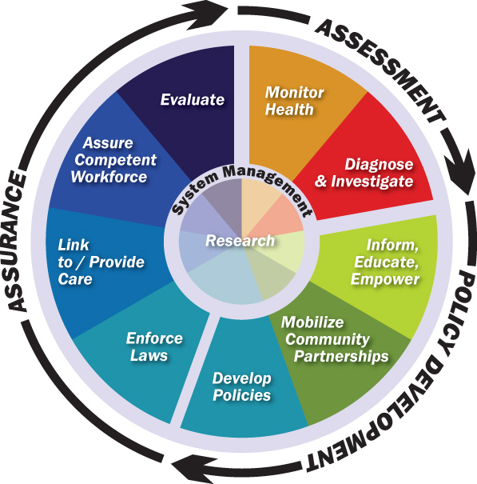

- Monitor Health
Assess and monitor population health status, factors that influence health, and community needs and assets.

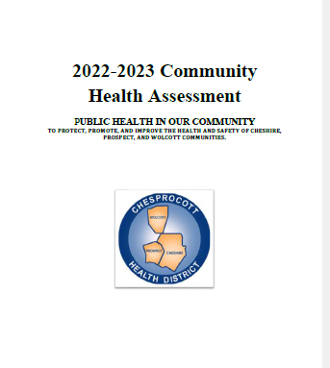
Chesprocott Health District strives to provide services and programs that reflect the needs of our communities. We determine those needs by conducting a Community Health Needs Assessment (CHNA). During the past year our health educator collected health data, conducted interviews, and collected information from a health needs assessment survey that we shared on social media sites including all three community Facebook pages and, on our website,


The health district not only uses the data from our Community Health Needs Assessment, but we also use other surveillance systems, information systems and community reports to monitor the health of our community. This information assists us in making data-driven decisions for the programs we plan and implement and partners we collaborate with.

CT DATA
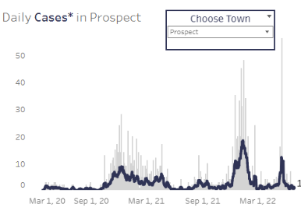
CT Data is a website that contains extensive data on a variety of topics including health and healthcare, housing, demographic and population and children and family data. We used this site extensively when creating CHNA and researching demographic information including poverty levels census information. The website contains an extensive database on COVID-19 tracking information which allowed us to look at each municipal COVID-19 data.

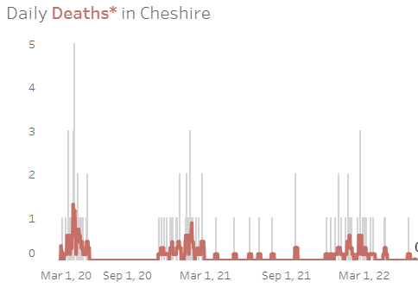

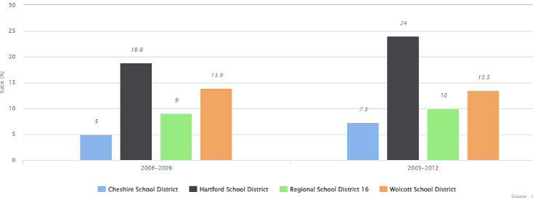

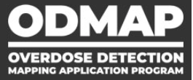
ODMAP/EPI Center

As an agency with interests in public safety and health we are provided access into the Overdose Detection Mapping Application Program (ODMAP). This website provides real-time suspected overdose data across our jurisdiction which helps support public safety and local public health. EPI Center is another database that allows local health departments to access hospital overdose data should a person be taken to an emergency room or urgent care facility.

CT WIZ
This is Connecticut’s secure web-based immunization information system. The website tracks and records administration of immunizations for all Connecticut’s children and
keeps records of all adult COVID-19 vaccinations. In the past year a public portal was created, and CT residents can access their vaccination records on this site.

GWHP
The Greater Waterbury Health Partnership is a collaboration of many regional health partners including Chesprocott. Every three years a Community Health Needs Assessment is funded, and the partners consider options to address the needs of the residents in the Greater Waterbury area towns which include Cheshire, Prospect and Wolcott. The Director of Health serves on the Executive Committee and has participated in all Community Health Needs Assessments, Community Health Improvement Plans, well-being reports and strategic planning. The information shared and relationships fostered has provided numerous resources and opportunities for improvement in health services.

CTEDESS/Maven
The CT DPH provides the health district communicable disease data and disease reporting through this web-based electronic disease surveillance system. Not only do we access disease data, but we manage elevated blood lead levels cases through this system. We receive daily updates on over 80 reportable diseases, emergency illnesses and health conditions that are declared reportable by the Commissioner of DPH.

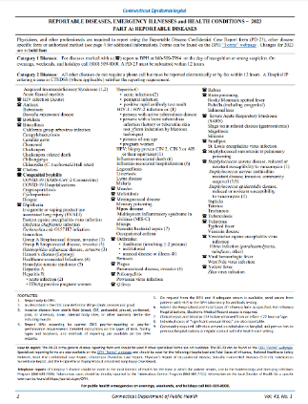
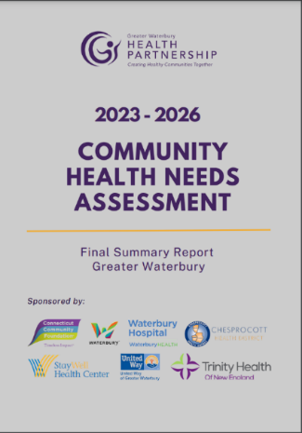

- Investigate Health Problems ProPProblemsProblems

Investigate, diagnose, and address health problems and hazards affecting the population.

Communicable Disease Surveillance
The Health District receives communicable diseases reports from various sources including the CT DPH, hospitals, local doctors and first responders. Each January the CT DPH releases a list of communicable diseases, emergency illnesses and other health conditions that are required to be reported to the health district per Connecticut General Statute 19a-215. We receive mailed paper reports and monitor electronic reports through the Connecticut Electronic Disease Surveillance System (CTEDSS). The following is a sampling of communicable disease cases reported in the past.
Reports Reviewed | 2020-2021 | 2021-2022 | 2022-2023 | 2023-24
Lyme/Tickborne illness | 56 | 54 | 71 | 129
Foodborne Illness | 15 | 16 | 26 | 27
Sexually Transmitted Diseases | 104 | 63 | 52 | 48
Group A/B Streptococcus & MRSA | 21 | 15 | 11 | 28
Hepatitis B & C | 62 | 79 | 113 | 177
Influenza | 1 | 53 | 157 | 249
COVID-19 (lab confirmed) | 7326 | 11178 | 3942 | 476
RSV | - | - | - | 40
** These numbers reflect the number of cases from July 1 to June 30th of those years above
Childhood Lead Poisoning
In 2021 CDC recommended and Connecticut adopted lowering reportable lead blood levels from 5 μg/dL to 3.5 μg/dL. Effective January 1, 2023, any blood level cases at or equal to 3.5μg/dL is required to report to CT DPH and local health. Every case is contacted by our public health nurse who provides educational material, guidance and follows each case. Our Environmental Health Specialists conduct a comprehensive epidemiological investigation for all cases that report blood lead levels of equal to or above 15μg/dL. Our goal is to educate parents on lead hazards and reduce environmental lead exposure and lead poisoning.
Chesprocott Public Health Nurses followed up with 26 elevated capillary blood lead level reports and 1 venous blood lead level.

Fees for Service:
Environmental Health
Number of Day Care Centers Inspected | 18
Number of Salon Inspections | 73
Number of Soil Tests Completed | 93
Number of Well Permits | 32
Number of additional reviews – B100s | 227
Number of Public Pools sites in the district | 19

Environmental Health Complaints

- Inform and Educate

Communicate effectively to inform and educate people about health, factors that influence it and how to improve it.
January is Radon Awareness Month 2023-24
In January our health district promoted radon awareness month. In partnership with the CT DPH, we received 100 home radon test kits and distributed them throughout the district.
The highest numbers found were 35.9 in Cheshire, 8.8 in Prospect and 5.0 in Wolcott.
If a resident receives high results, we send them a letter with a list of state approved mitigation system contractors.

Chesprocott Seasonal Newsletters
Chesprocott continues to do seasonal newsletters to inform the public about important health topics and upcoming programs and events. These newsletters were distributed to senior centers, town halls, libraries, and at community centers. They contained important information ranging from disease trends, mental health wellness tips, and a calendar of events.
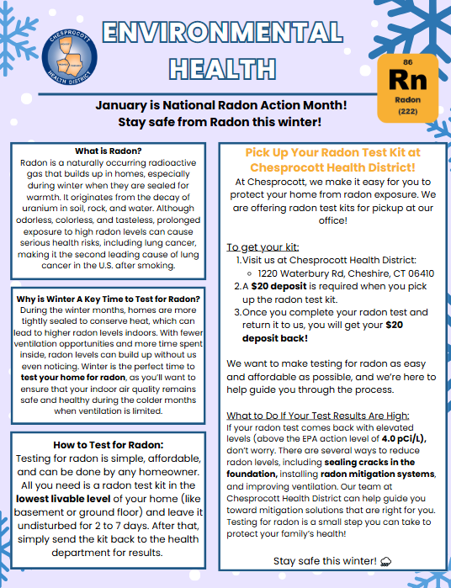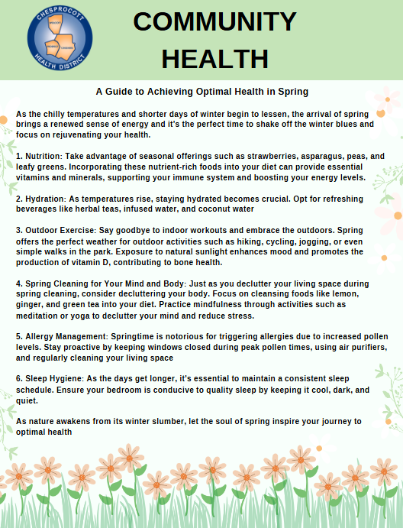
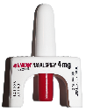
Community Narcan Training
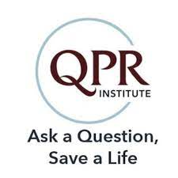
Narcan training is an essential part of overdose prevention education. The health district collaborates with community prevention partners Cheshire Human Services, Wolcott Citizens Against Substance Abuse (CASA), and Wolcott Volunteer Ambulance to provide training in all our communities. The intent of these trainings is to empower community members, family, and friends to help save lives. Participants learned about opioids, what Narcan is, how to administer it, the Good Samaritan Law, and local resources for assistance. Participants received Narcan kits which contained 2 doses of Narcan.

QPR (Question, Persuade, Refer) Suicide Prevention Training
The QPR gatekeeper training for Suicide Prevention is a brief educational program designed to teach “Gatekeepers” – those who are strategically positioned to recognize and refer someone at risk of suicide (parents, educators, health professionals, coaches, etc.) the warning signs of suicide crisis and how to respond by questioning, persuading and referring the person to appropriate resources. Our Public Health Educator collaborated with Meriden Health Department, Wolcott CASA and other organizations to hold these important trainings throughout our communities.
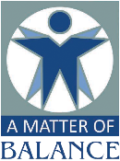
Matter of Balance (MOB)
(MOB) is specifically designed to reduce the fear of falling and improve activity levels among community-dwelling older adults. The program includes eight two-hour classes presented to a small group of 8-12 participants led by trained coaches. The program enables participants to reduce the fear of falling by learning to view falls as controllable, setting goals for increasing activity levels, making small changes to reduce fall risks at home, and exercise to increase strength and balance.
- Community Engagement

Strengthen, support, and mobilize communities and partnerships to improve health.
Collaboration with First Responders
Chesprocott has a very close partnership with our community first responders and those employees who respond to emergencies. We partner with them on Drug Take Back Days, CPR training, Fire Safety and more.

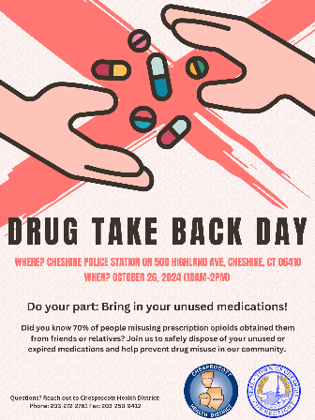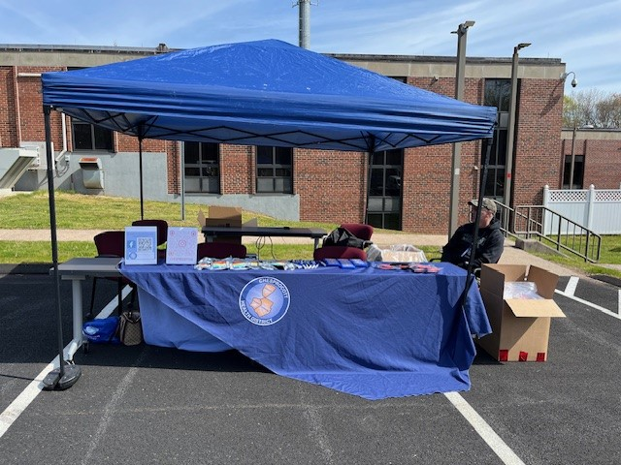
Member of Three Towns Local Prevention Councils
Chesprocott is a member of all three town’s Local Prevention Councils that focus on the prevention and education of substance use disorder including opioid, tobacco, cannabis and alcohol use.
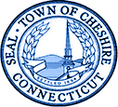
Member of the Three Town’s Chambers of Commerce
Chesprocott is a member of each town’s chamber and business association that assists us in networking and creating new town partnerships to expand our mission, promote health initiatives, help educate them about public health topics, and build relationships with influential community stakeholders in the community.

Cheshire Health and Wellness Coalition Chesprocott, the Cheshire Chamber of Commerce and Elim Park and other health and local businesses collaborate in the implementation of the town-wide health and wellness Coalition that offers health seminars, events and guest speaker on important health topics

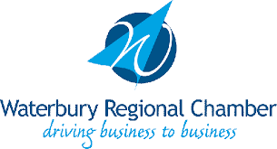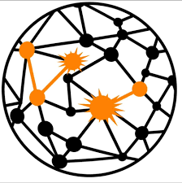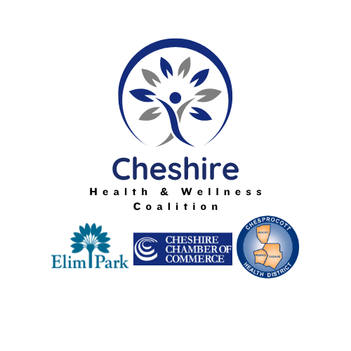

Throughout the year our Public Health Nurses, Community Outreach Coordinator, Emergency Response Coordinator and Public Health Educator attended many community events where vaccinations were provided, vaccine test kits and face masks were distributed, blood pressure was checked, and health related materials was shared.


Health Seminar at Elim Park (25 attended)
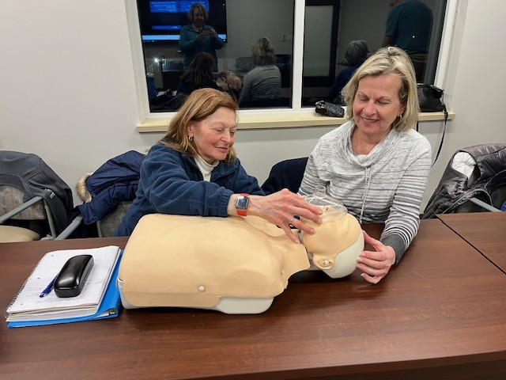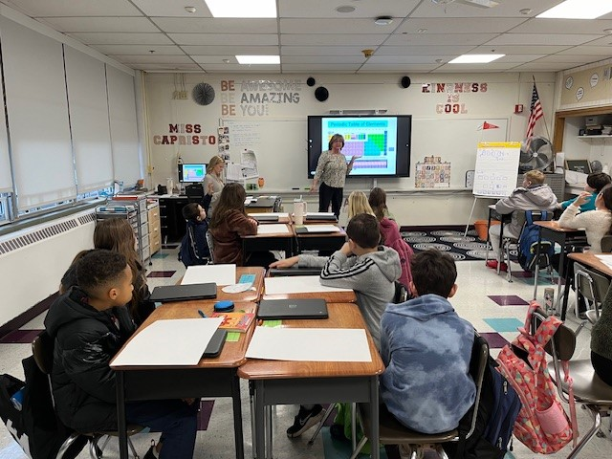
MRC Volunteers CPR Training (10) Teaching students about Radon (120)

- Develop Policies and Plans

Create, champion and implement polices, plans, and laws that impact health.
Volunteer Management and MRC (Medical Reserve Corps) Policy
MRC volunteers are trained to assist during public health emergencies such as pandemics, natural disasters, or bioterrorism events. This gives Chesprocott a surge capacity for skilled help when local healthcare systems are overwhelmed.
Example: During COVID-19, MRC volunteers supported vaccination clinics, testing sites, and contact tracing efforts.
MRC members can also support routine health initiatives, such as: Health screenings, Flu vaccination clinics, Health education at community events
This extends Chesprocott’s reach into the community without putting extra strain on staff or budgets.
MRC volunteers include nurses, doctors, pharmacists, EMTs, and non-medical personnel with admin or logistical experience. This gives Chesprocott a flexible, interdisciplinary team that can be deployed based on the need.

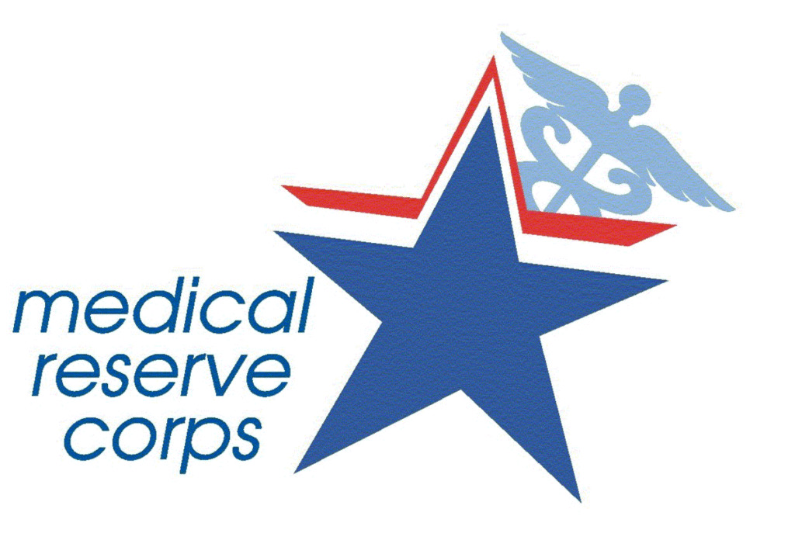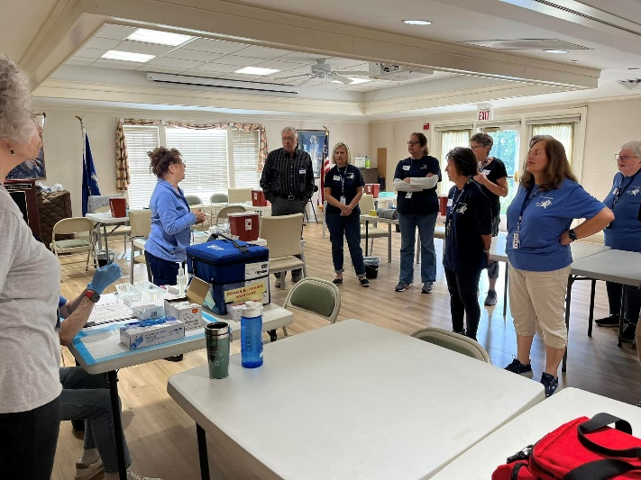
- Public Health Laws
Utilize legal and regulatory actions to improve and protect public health
Public health laws influence the health of the entire population. Environmental Health laws include food sanitation, lead inspections, drinking water quality, clean air, waste-water disposal, and vector control. Infectious disease laws include outbreak investigations, immunizations, infectious disease reporting, quarantine, tuberculosis enforcement and sexually transmitted infections contact tracing. Chronic disease laws include sales of tobacco products to youth, smoke free ordinances and adoption of bike lanes while injury prevention laws include seat belt laws, helmet laws, speeding limits and harm reduction.
Our Environmental Health staff are key to promoting and protecting the health of the population. While they enforce the CT Public Health Code and applicable state and local ordinances, they gain compliance through educating our regulated entities including restaurants, day care centers, public pools and salons.
Educating the public and the regulated facility on the meaning, purpose, benefits of the law and compliance requirements builds partnerships.
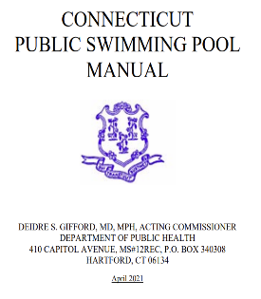
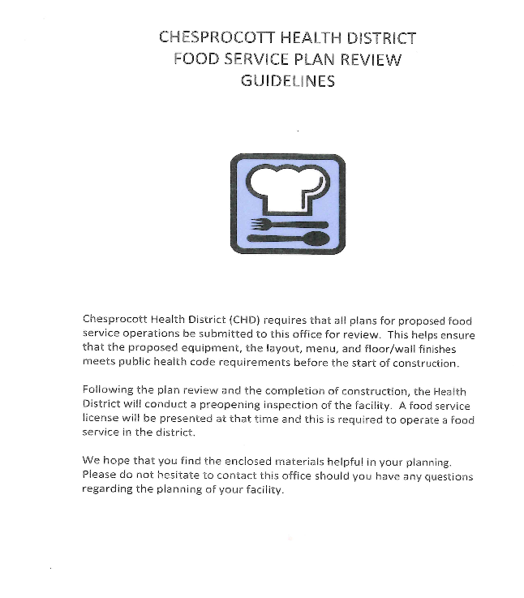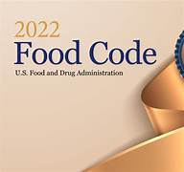

Beginning the week prior to Memorial Day, the environmental health staff collect weekly samples of all bathing water within the district. In the case of elevated levels of E.coli (see the green line) we resample and close the area to the public until the levels are safe.




Mixville Recreation Area Cheshire Woodtick Recreation Area Wolcott

- Access to Health Care

Assure an effective system that enables equitable access to individual services and care needed to be healthy.
Vaccines Provided
CHD clinical staff and Medical Reserve Corp (MRC) members held many vaccination clinics throughout our district providing covid vaccinations and flu shots.
 | # Covid Clinics | # Flu Clinics
Cheshire | 3 | 6
Prospect | 0 | 1
Wolcott | 0 | 1

Covid-19 | Flu Regular Dose | Flu High Dose
183 | 320 | 319

A total of 11 clinics were held throughout the district. Partnering agencies included local schools, senior centers, and at community events
Cheshire: Cheshire Public Schools, Cheshire Academy, Elim Park, Cheshire Senior Center, Chesprocott office
Prospect: Prospect Senior Center
Wolcott: Wolcott Senior Center

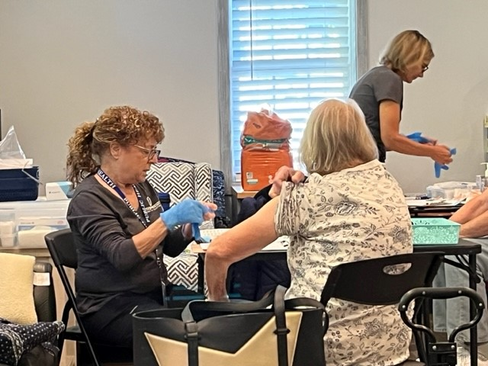
- Maintain a Competent Workforce

Build and support a diverse and skilled public health workforce.
Each year the environmental health staff are required to attend lead code enforcement update seminars and renew their Lead Inspector and Lead Risk Assessor certificates. This year our sanitarians became certified in Phase I and Phase II Subsurface Sewage and Food Inspector Certification by the CT Department of Public Health. They also earned certification as pool and spa operators. Emergency Preparedness staff attend the annual NACCHO Emergency Preparedness Conference and Community Health staff attend the annual CPHA and Flu Conference.
Professional Organizations
Staff at Chesprocott are members of many professional organizations. These organizations provide continuing education, health alerts, research journals, best practices, data and advocacy.

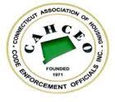
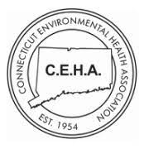
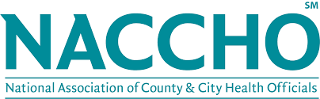

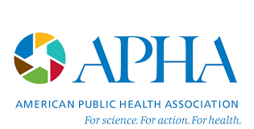
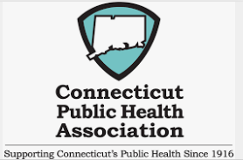
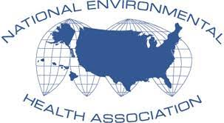

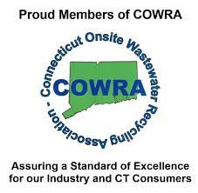

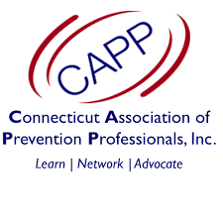

- Evaluation

Improve and innovate public health functions through ongoing evaluation, research, and continuous quality improvement.
In May 2023 to May 2024, Chesprocott hired an intern from the UCONN Master of Public Health Degree program to research and write our Community Health improvement Plan (CHIP). This plan is based on data gathered through the 2023 Community Health Needs Assessment (CHA) and outline priorities, goals, and actions to address key health issues identified by the community.
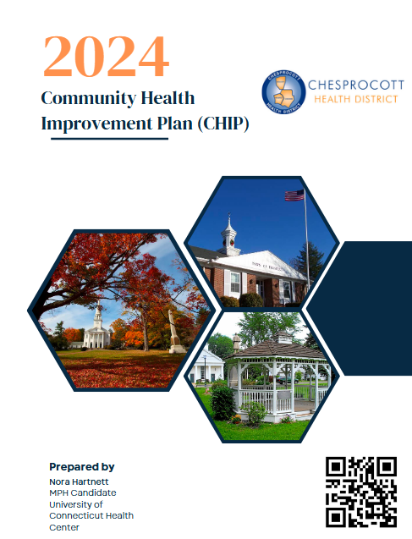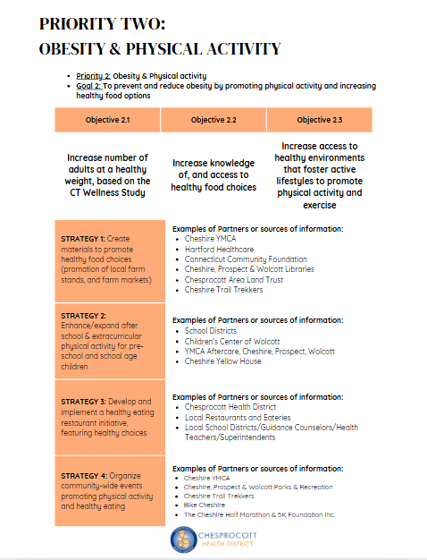
Our Main Priority Areas Include:
Priority Area 1: Mental and Behaviroa Health
Priority Area 2: Obesity and Physical Activity
Priority Area 3: Addiction and Substance Misuse
Priority Area 4: Oral Health
- Evidence Based

Build and maintain a strong organizational infrastructure for public health.

The Chesprocott Health District (CHD), serving Cheshire, Prospect, and Wolcott, can enhance its infrastructure by focusing on several key areas that align with its mission to protect and improve community health.​
1. Facility Expansion and Modernization
CHD is currently in the process of relocating to a new building, which will temporarily close its licensed clinic. Upon completion, this move will provide an opportunity to expand services, such as offering more immunizations, screenings, and health education programs. Upgrading the facility to accommodate these services will strengthen the district's capacity to meet community health needs.
2. Strengthening Emergency Preparedness
CHD's mission includes promoting health and safety before, during, and after emergencies. Enhancing infrastructure in this area could involve upgrading communication systems, improving emergency response coordination, and increasing public awareness through training programs. Engaging community volunteers and providing resources for emergency preparedness can further bolster the district's readiness for various situations. ​
3. Community Health Initiatives
CHD's Community Health Division focuses on improving health outcomes through outreach, education, and support services. Infrastructure improvements creating areas for community meetings, and enhancing facilities to support programs addressing mental health, nutrition, and chronic disease prevention. These initiatives aim to foster a healthier community environment.
4. Collaboration and Resource Mobilization
CHD can enhance its infrastructure by collaborating with local organizations, businesses, and community members to leverage resources and expertise. Joint efforts can lead to the development of shared spaces, coordinated health services, and community-driven initiatives that address specific health challenges. Such collaborations can result in more effective and sustainable health improvements.

5. Data-Driven Decision Making
Conducting regular Community Health Assessments (CHAs) and developing Community Health Improvement Plans (CHIPs) are essential for identifying health priorities and planning interventions. Investing in data collection tools, analytical capabilities, and community engagement processes will enable CHD to make informed decisions and track progress over time. This approach ensures that infrastructure improvements align with the actual needs of the community. ​The District also has allocated funds towards an electronic software program for our sanitarians to conduct their inspections out in the field. This will streamline this process and eliminate unnecessary paperwork.
By focusing on these areas, Chesprocott Health District can strengthen its infrastructure, enhance service delivery, and improve the overall health and well-being of the communities it serves.
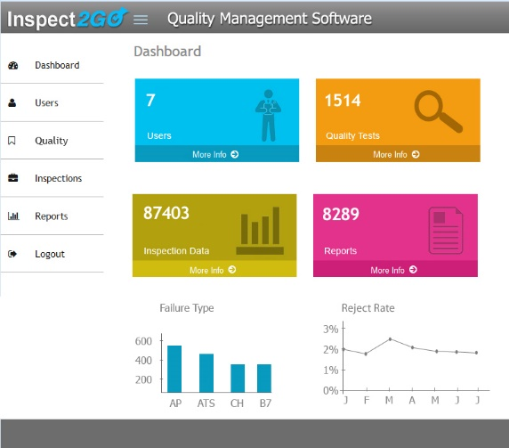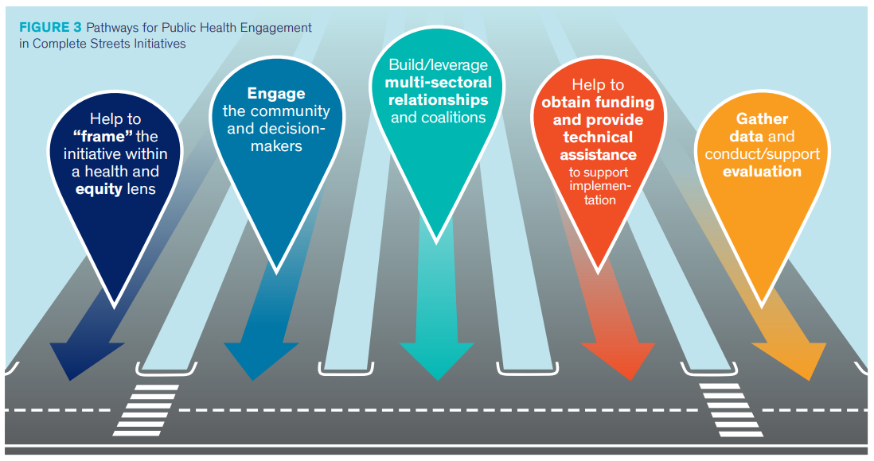

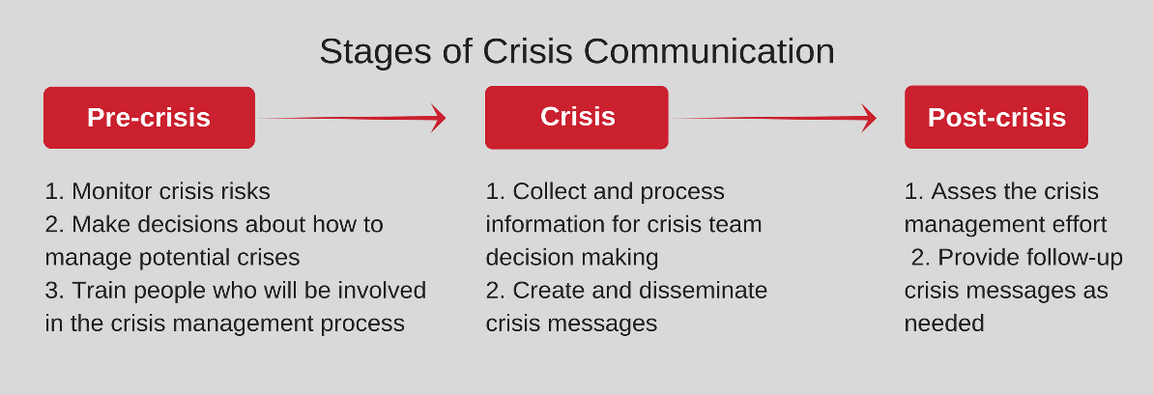

Department Contact Information

Chesprocott Health District
1220 Waterbury Rd
Cheshire, CT 06410
Main Office Number: 203-272-2761
Fax: 203-250-9412
Website: www.chesprocott.com

